This is a pdf that contains notes from reviews gotten from the customers during our WordPress work in progress website designs check-in.
- Our services grid needs to be wider, take up more horizontal space
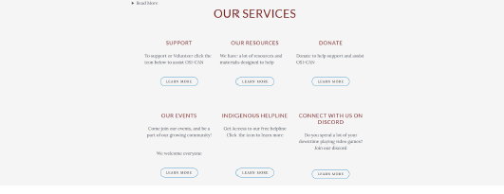
- “Our vision” image is oddly small, either we remove it or make it bigger

- Target demographic, the brief description is good but have a link to another page that shows all the individual target demographics. So that if you want to update it you only need to update the one page
- The text on the homepage was too big, and the color grading was not too perfect
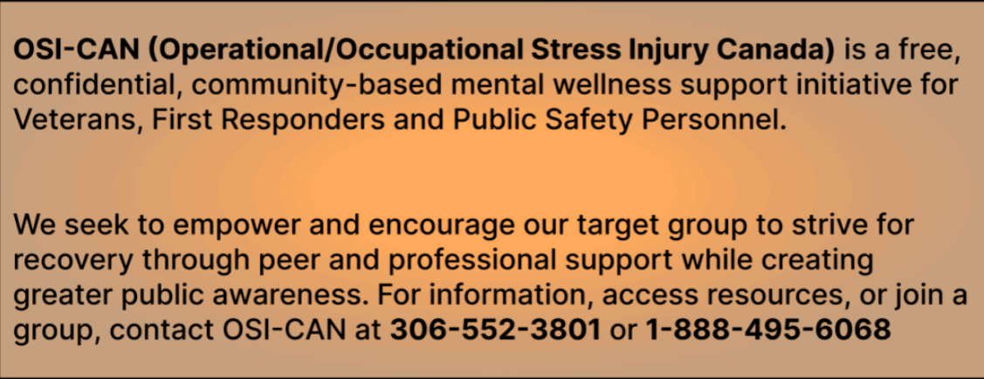
- The size was of the top picture in the about page was too big

- Read more was not visible enough and was not part of the text which might be skipped by the user or not noticed at all
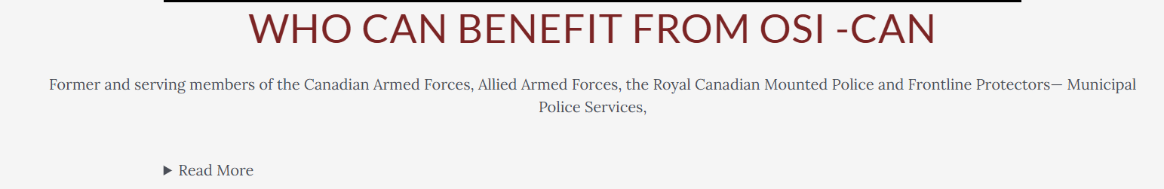
- Combining of Programs and Events on the navigation bar was not ideal due to the importance of the two.
- The carousel was not too perfect and was also distracting
- The text on the suicide helpline was too small and might be hard for clients to read
- Our services and its sub containers should not be located down in the home page, so it is easily accessed by the user when entering the website due to its importance
- The grouping of content in the resources page did not have text beside them which was not advisable because it would not give the users and understanding on what each grid of content card layout is about.
- We need to have a dedicated contact page, that has phone number, google map location, and social media handles
- The image in the events page should have images with same consistent size
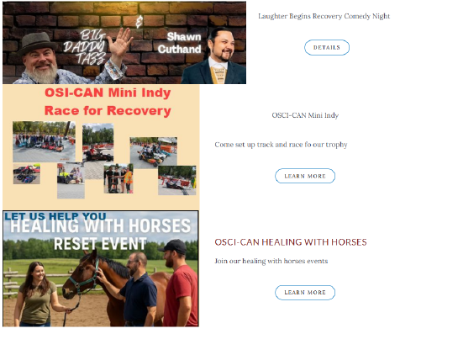
- We should make “call know” and “Donate Now” the same page

- Clients liked the fact that we used similar themes and colors to their current website.
- The Above Header, which is a note for people who are in distress and need urgent help, we need to increase the font for it.

- Less Imagery on the front page
- Implement large-scale photos with text on top to adjust the opacity.
- Suggested us to change the “Support” Menu to “Support Programs”
- Sponsor logo should be on every page just like footer.
- The homepage needs to be catchier.

